Desa Soropadan Rt. 09/05, Kecamatan Pengasih,

Kelurahan Tawangsari, Kabupaten Kulonprogo

Wates – Yogyakarta, Indonesia (55652)

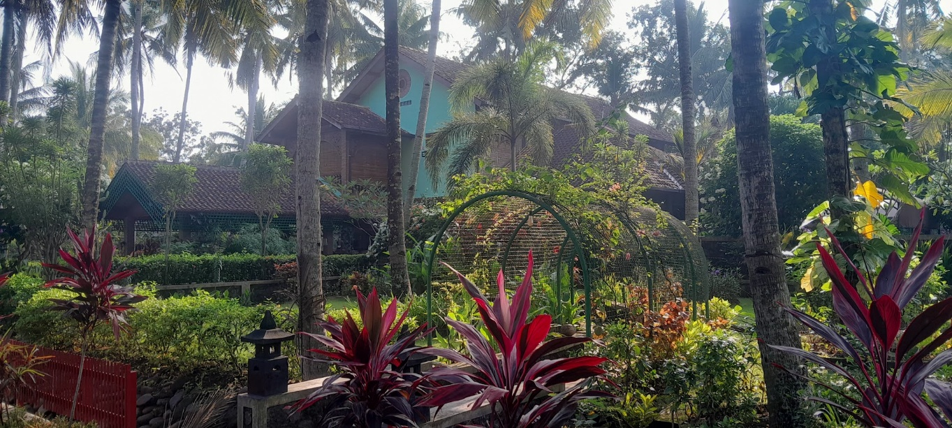

# Welcome to Our Wellness Retreat

Immerse yourself in serenity at Hacienda Tranquillity Retreat. our retreat offers a nurturing space for personal growth, relaxation, and healing. With a harmonious blend of nature, culture, and mindfulness practices, each guest finds space to reconnect with themselves and the world around them.

# LOCATION:

Hacienda Retreat, nestled in the lush countryside of Yogyakarta,   
is located in the small village of Soropadan. The Indian Ocean is just a short 10-minute drive away and inland the mountains of Central Java can be seen in the distance. Wates, the nearest town is located on National Highway 3 – the Yogyakarta to Jakarta road; Wates is served by a Mainline Railway Station and a Bus Station with services to cities throughout Java.

Yogyakarta is an hour away and the International Airport (YIA) just a short 10 minute’s drive.

Soropadan is our local kampong (farming village) and there are many short walks of interest from the Hacienda along riverbanks, orchards and rice fields, many with stunning views of the mountains of Central Java. The area around Soropadan right down to the Indian Ocean is relatively flat and great for cycling (mountain bikes are available at the Hacienda).

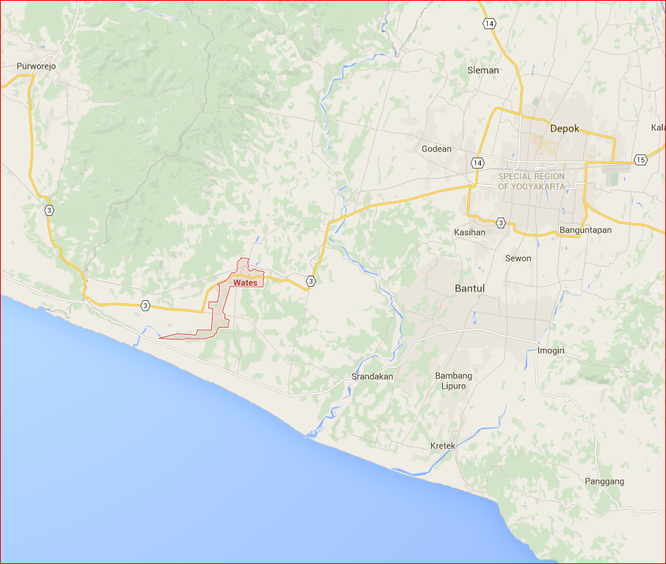

# *Wates in the Yogyakarta Region on National Highway 3*

# FACILITIES:

Hacienda Retreat features 2-storey country farmhouse style accommodation built with Java tradition in mind but constructed to European standards. The Retreat sits in 5,000 metres of gardens and orchards. In the orchards you can find banana, grapes, coconut, mango, passion fruit, guava, jack fruit, orange, and lemon, while in the vegetable gardens you can find peanuts, kankung, lemon grass, kaffir lime, peas, cassava, celery, turmeric, garlic, chili and ginger depending on the season.

# D:\Users\aroderick\Pictures\Soropadan\IMG_0283.JPG

*The Veranda*

*The Gazebo*

Accommodation features Barn style family accommodation suitable for up to 6 guests and a Master Suite. Within the main home there are 2 further bedrooms which are suitable for double occupancy.

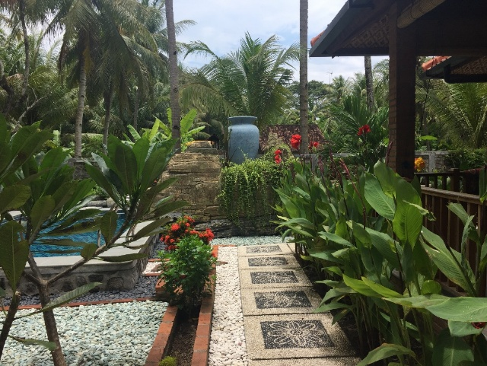

*The Rear Garden*

The pool garden features a small plunge pool and a fish pool, both with unique waterfall features. The fish pool is stocked with gourami and tilapia.

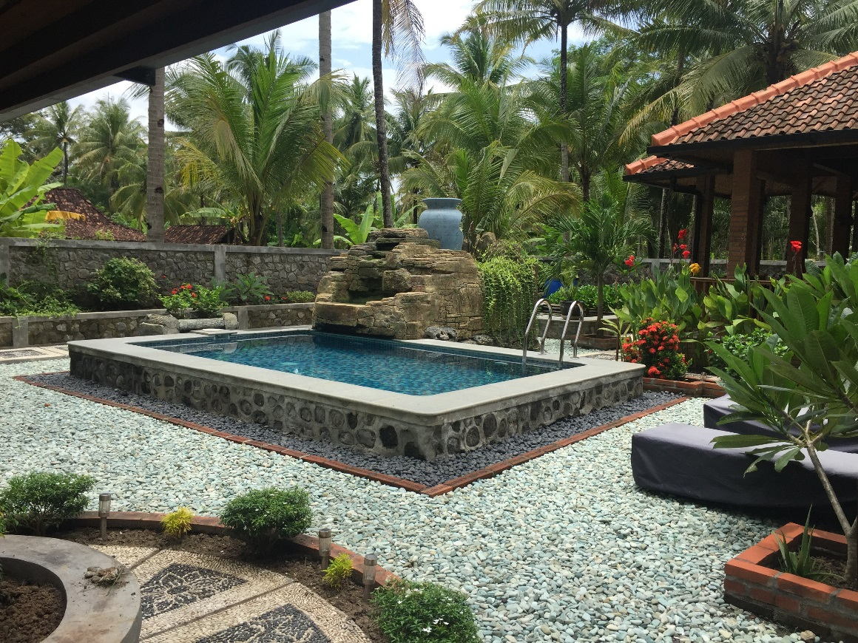

*The Plunge Pool*

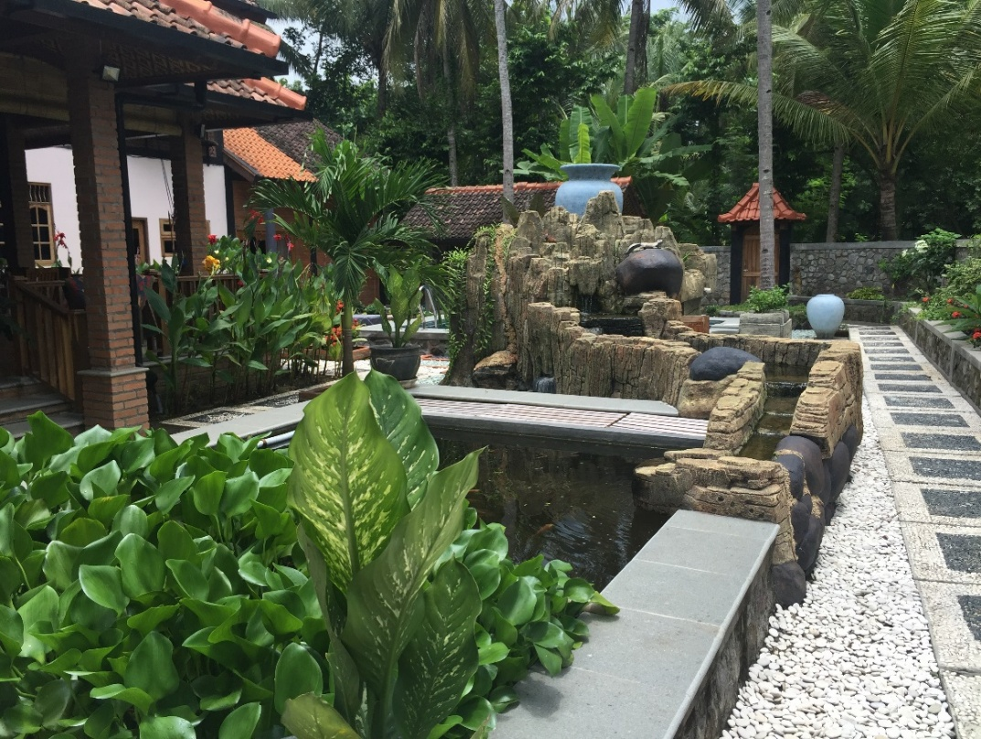

*The fish pool*

The gardens also feature our own Chicken House and Beehives which also produce fresh eggs and honey for the Hacienda table.

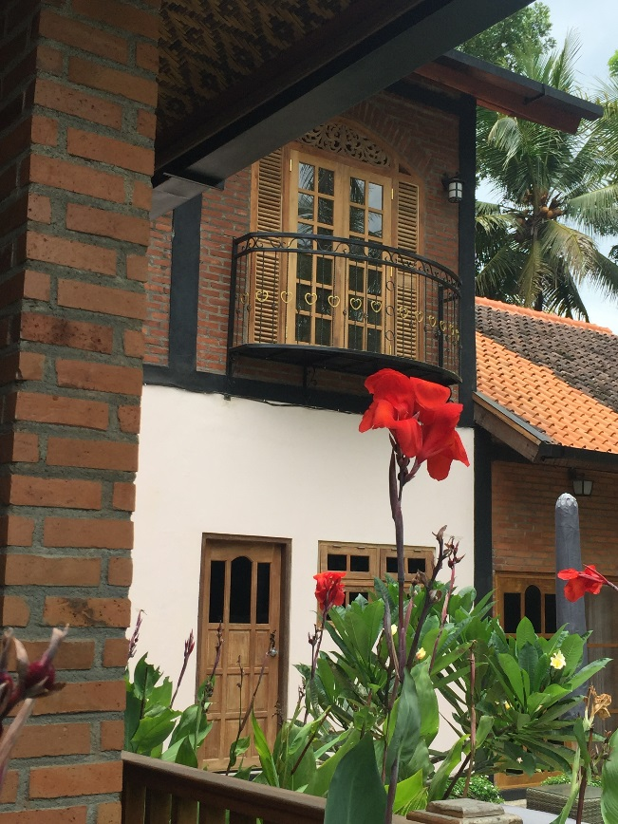

The Garden – Lilies in the Waterfall

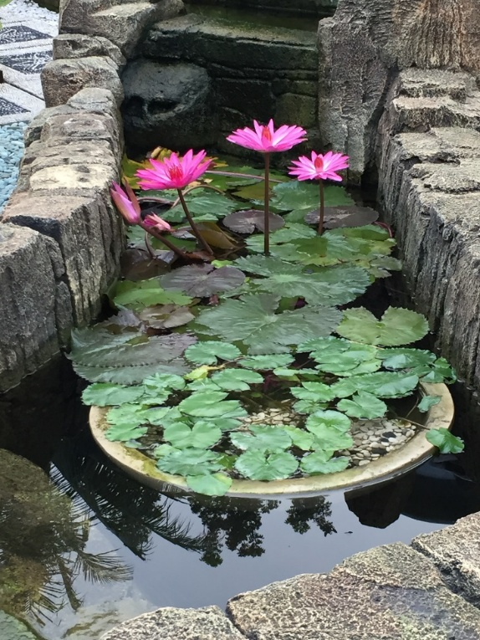

# TYPES OF BOARD:

Hacienda Retreat has a flexible approach to boarding and can provide basic bed & breakfast, bed & breakfast with evening meals as well as a full-board option. As all meals are freshly cooked it is usual to order meals the evening before or at breakfast.

# MEALS:

Daily menus contain, Indonesian, Asian and Western dishes and special orders are catered for wherever possible. We cater for vegan, vegetarian and halal diets, as well as offering a variety of international dishes.

In general, all fruit and vegetables are grown in our own garden. Eggs are all laid by our own hens. Many herbs and spices are also home grown.

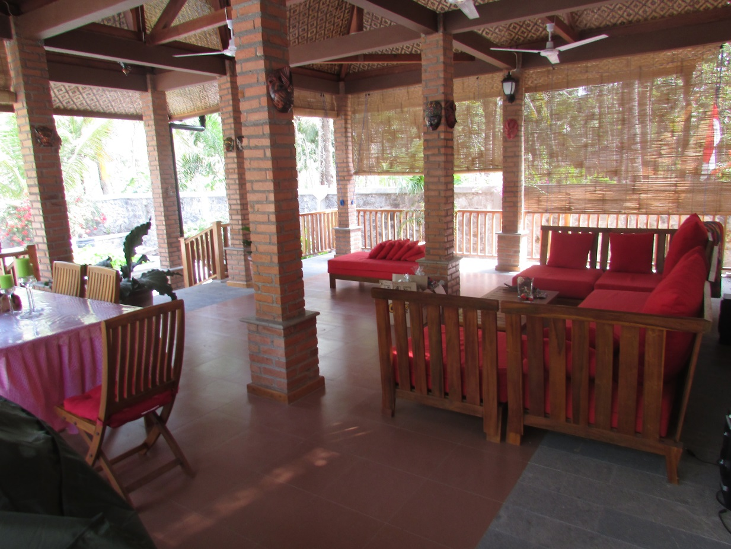

*The Veranda*

# Welcome to Our Wellness Retreat

Immerse yourself in serenity at Hacienda Tranquillity Retreat. Nestled in the lush countryside of Yogyakarta, our retreat offers a nurturing space for personal growth, relaxation, and healing. With a harmonious blend of nature, culture, and mindfulness practices, each guest finds space to reconnect with themselves and the world around them.

# Our Offerings

* Daily yoga and meditation sessions (all levels welcome)
* Traditional Javanese and Ayurvedic massage therapies
* Healthy, plant-based meals made from local produce
* Nature walks, journaling, and breathwork
* Optional workshops and cultural immersion experiences
* Bilingual sessions in English and French (on select retreats)

# Your Stay

Enjoy peaceful accommodation in traditional Javanese-style rooms, thoughtfully designed for rest and rejuvenation.   
Choose from private or shared rooms, all surrounded by gardens and natural beauty.

# Location & Facilities

Located just 45 minutes from Yogyakarta city, our retreat spans two charming homes and a nearby garden sanctuary.   
Facilities include an open-air yoga shala, massage rooms, a community lounge, and peaceful walking paths among rice fields.

*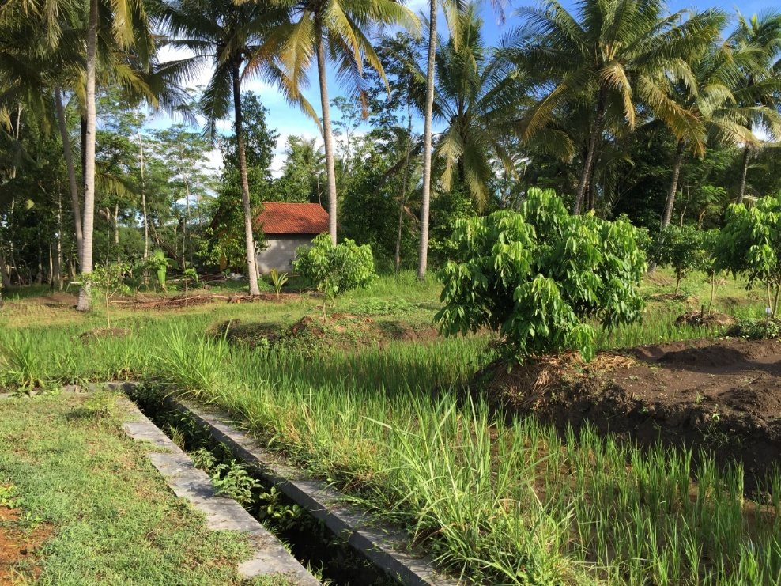*  
*Local field with Longan Trees*

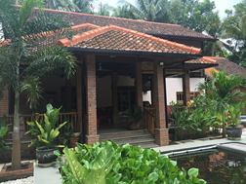

# MASSAGE:

One of the great luxuries of Indonesia is the traditional Javanese Massage. At Hacienda Retreat we are blessed with the services of a top professional masseuse – Bu Deh.

It’s great to relax at the end of the day with a massage before dinner. Bu Deh mixes all her own herbs and spices for the treatments and body rubs used in her traditional massage treatments.

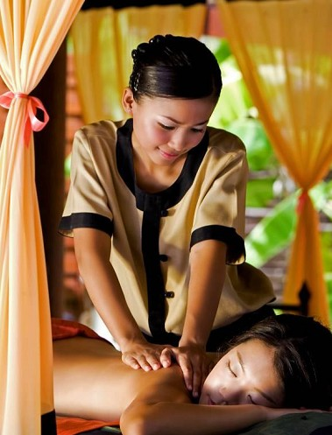

*Traditional Javanese massage*

Massages can be arranged by the poolside, in the shade of the Veranda or in the privacy and comfort of your own room.

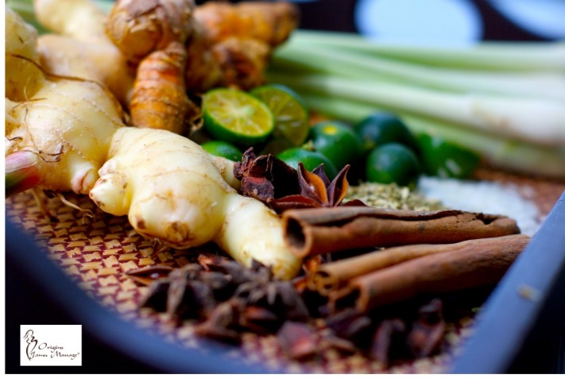

***S****election of Herbs & Spices used in traditional Javanese Massage*

# WEATHER:

Hacienda Retreat enjoys a favoured, pollution-free climate, cooled by the breezes of the Indian Ocean and shaded by coconut palms, there is no need for air conditioning (though ACs available in some rooms) and virtually no mosquitoes to worry about.

*Main Garden*

## Dry Season

The dry season in Wates runs from May to October. At this time, you may still see the odd rain shower, but it’s certainly much drier than the rest of the year. It’s also the hottest time of the year, although only a few degrees hotter than the relatively stable year-round temperatures. Expect average daily highs of 30°C, with overnight lows of 20°C.

## Wet Season

The rest of the year, from November to April, is monsoon influenced. The wettest months are between December and March, however, it’s important to note that it does not rain all day - most downpours come in the late afternoon, with dry but often humid weather during the day.

Average midday temperatures are around the 28°C mark, falling back to 18°C overnight.

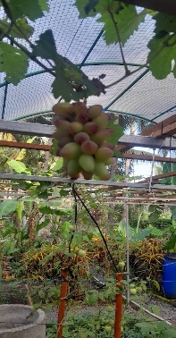

*The small Vineyard*

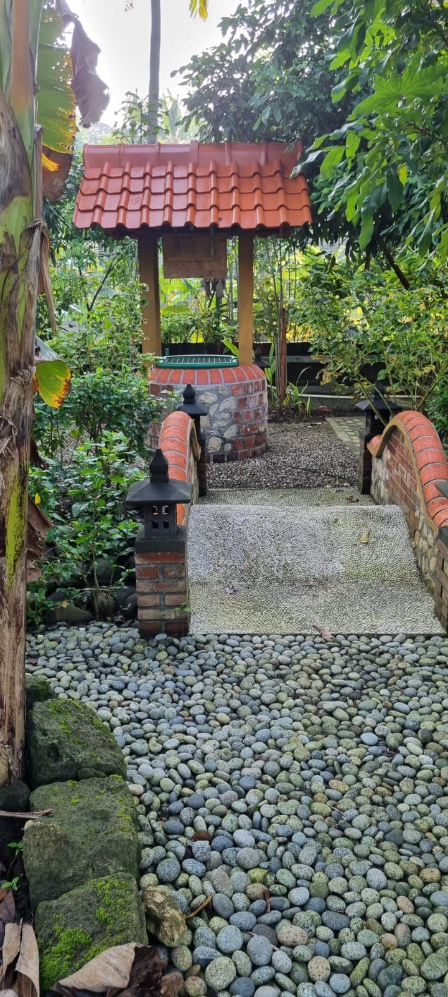

*The Wishing Well*

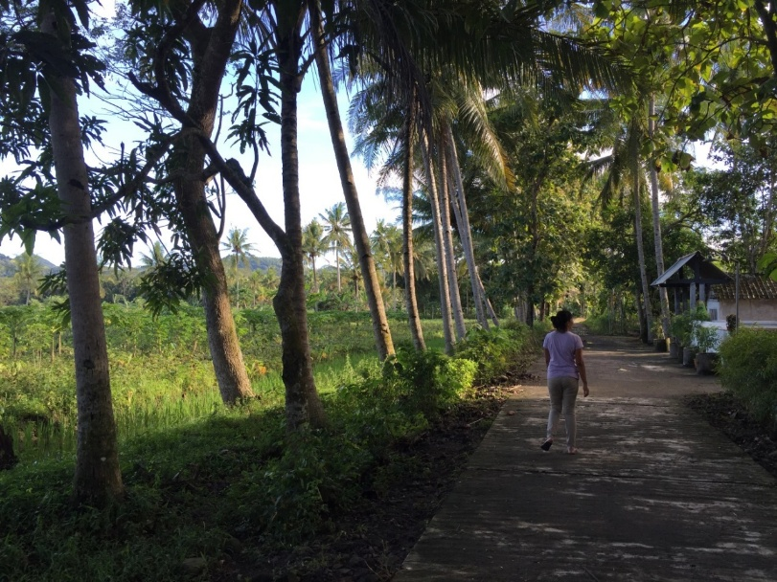

*Soropadan Village walk*

# LOCAL ATTRACTIONS/DAY TRIPS:

Trips can be arranged by the Hacienda to any of these destinations which require motor transport:

## Borobudur

The magnificent Borobudur temple is the world’s biggest Buddhist monument, built in the 9th century during the reign of the Shailendra dynasty, the temple’s design in Gupta architecture reflects India's influence on the region, yet there are enough indigenous scenes and elements incorporated to make Borobudur uniquely Indonesian. This awe-inspiring monument is truly a marvel. After a visit here you will understand why it is Indonesia’s most visited tourist attraction and a famous icon of Indonesia’s cultural heritage.

Located on the island of Java, the temple sits majestically on a hilltop overlooking lush green fields and distant hills. It covers an area, measuring 123 x 123 meters. The monument is a marvel of design, decorated with 2,672 relief panels and 504 Buddha statues. The architecture and stonework of this temple has few equals. And is built without using any kind of cement or mortar!

The temple has remained strong even through ten centuries of neglect. It was rediscovered in 1815 during William Stamford Raffles’ time as Governor of Java, buried under volcanic ash. In the 1970’s the Indonesian Government and UNESCO worked together to restore Borobudur to its former majesty The restoration took eight years to complete and today Borobudur is one of Indonesia and the world’s most valuable treasures.

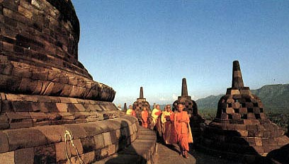

*Monks at Borobudur*

The temple is decorated with stone carvings in bas-relief representing images from the life of Buddha. Commentators claim that this is the largest and most complete ensemble of Buddhist reliefs in the world, unsurpassed in artistic merit.

This monument is both a shrine to the Lord Buddha and a place for Buddhist pilgrimage. The ten levels of the temple symbolize the three divisions of the religion’s cosmic system. As visitors begin their journey at the base of the temple, they make their way to the top of the monument through the three levels of Buddhist cosmology, Kama dhatu (the world of desire), Rupa dhatu (the world of forms) and Arupa dhatu (the world of formlessness). As visitors walk to the top the monument guides the pilgrims past 1,460 narrative relief panels on the wall and the balustrades.

The whole monument itself resembles a giant stupa but seen from above it forms a mandala. The great stupa at the top of the temple sits 40 meters above the ground. This main dome is surrounded by 72 Buddha statues seated inside perforated stupa.

Historians suggest that the name of Borobudur comes from the Sanskrit ‘Vihara Buddha Uhr’ or the ‘Buddhist monastery on the hill’.

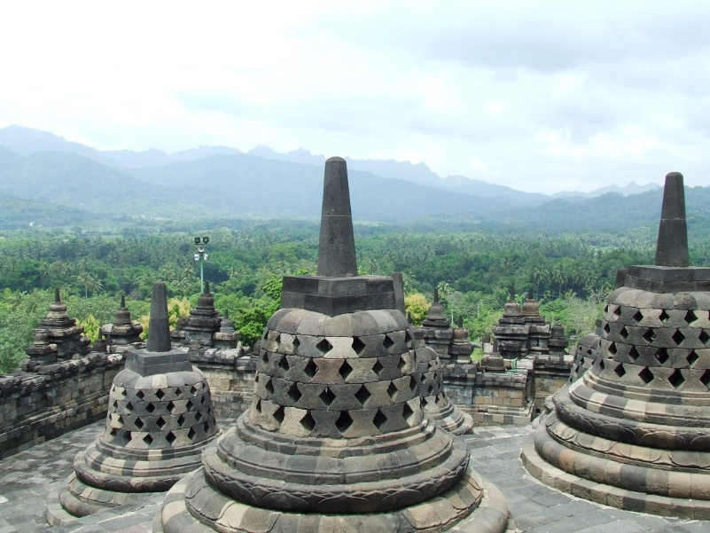

## Prambanan

Built in the 10th century, this is the largest temple compound dedicated to Shiva in Indonesia. Rising above the centre of the last of these concentric squares are three temples decorated with reliefs illustrating the epic of the Ramayana, dedicated to the three great Hindu divinities (Shiva, Vishnu and Brahma) and three temples dedicated to the animals who serve them.

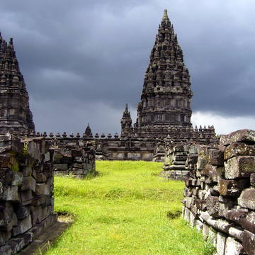

### Brief overview

Prambanan Temple Compounds consist of Prambanan Temple (also called Loro Jonggrang), Sewu Temple, Bubrah Temple and Lumbung Temple. Prambanan Temple itself is a complex consisting of 240 temples. All the mentioned temples form the Prambanan Archaeological Park and were built during the heyday of Sailendra’s powerful dynasty in Java in the 8th century AD. These compounds are located on the border between the two provinces of Yogyakarta and Central Java on Java Island.

While Loro Jonggrang, dating from the 9th century, is a brilliant example of Hindu religious bas-reliefs, Sewu, with its four pairs of Dwarapala giant statues, is Indonesia’s largest Buddhist complex including the temples of Lumbung, Bubrah and Asu (Gana temple). The Hindu temples are decorated with reliefs illustrating the Indonesian version of the Ramayana epic which are masterpieces of stone carvings. These are surrounded by hundreds of shrines that have been arranged in three parts showing high levels of stone building technology and architecture from the 8th century AD in Java. With over 500 temples, Prambanan Temple Compounds represents not only an architectural and cultural treasure, but also a standing proof of past religious peaceful cohabitation.

.

### Integrity

Prambanan Temple Compounds comprise of two groups of buildings which includes Loro Jonggrang, Sewu complexes, Lumbung, Bubrah and Asu (Gana). The 508 stone temples of various shapes and sizes are either in a complete and preserved condition or have been retained as ruins. This site includes all elements necessary to express its exceptional significance and is well maintained. There are no threats of development or neglect; however the area is prone to natural threats such as earthquakes and volcanic eruptions.

### Authenticity

Prambanan Temple Compounds contain the original structures that were built in the 9th century AD. The temples collapsed due to earthquake, volcanic eruption and a shift of political power in the early 11th century, and they were rediscovered in the 17th century. These compounds have never been displaced or changed. Restoration works have been conducted since 1918, both in original traditional method of interlocking stone and modern methods using concrete to strengthen the temple structure. Even though extensive restoration works have been done in the past and as recently as after the 2006 earthquake, great care has been taken to retain the authenticity of the structures.

### Cultural interest

Prambanan, named after the village, is the biggest temple complex in Java. It is actually a huge Hindu temple complex about 15 km north-east of Yogyakarta. Dedicated to the three great Hindu divinities, this temple with its decorated reliefs is an outstanding example of Siva art in Indonesia and the region.

It was built in the 9th century and designed as three concentric squares. In all there are 224 temples in the entire complex. The inner square contains 16 temples, the most significant being the 47 m high central Siva temple flanked to the north by the Brahma temple and to the south by the Vishnu temple. These three ancient masterpieces of Hindu architecture are locally referred to as the Prambanan Temple or Lorojonggrang Temple (Slender Maiden); the compound was deserted soon after it was completed, possibly owing to the eruption of nearby Mount Merapi.

A square platform is divided into concentric courts by square-plane walls. In the middle of the last enceinte stand the temples dedicated to the three great Hindu gods and three small temples dedicated to their animal vehicles (Bull for Siva, Eagle for

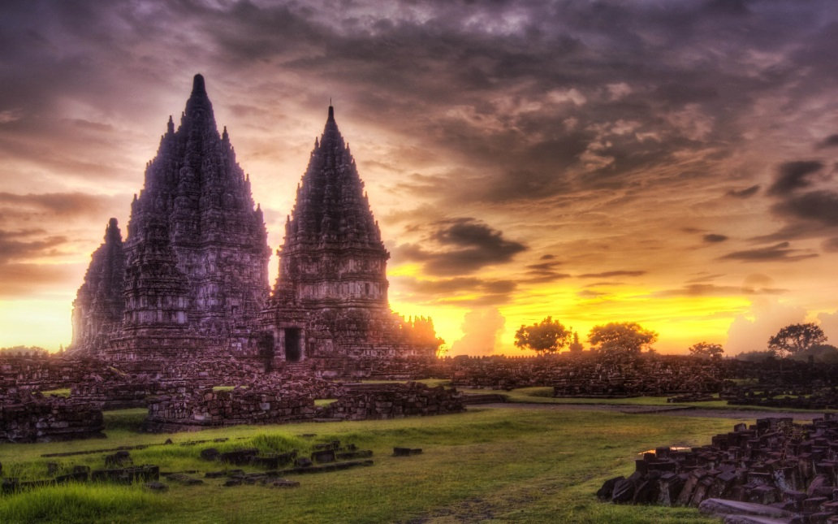

Brahma and Swan for Vishnu). Other minor temples were located at the entrance gates or outside the central enceinte (four ensembles).

The Siva temple had four statues: located in the centre chamber is the Siva statue; in the north chamber stands the Dewi Durga Mahishasuramardini statue; in the west chamber stands the Ganesha statue; and the south chamber contains the statue of Agastya. Inside the Brahma temple there is Brahma statue, and in the Vishnu temple there is the Vishnu statue. In the Vishnu temple is carved the story of Krasnaya, while the Brahma temple houses the continuous story of the Ramayana. The temples of Siva, Vishnu and Brahma are decorated with reliefs illustrating the Ramayana period (history of the Hindu hero Rama, written around 300).

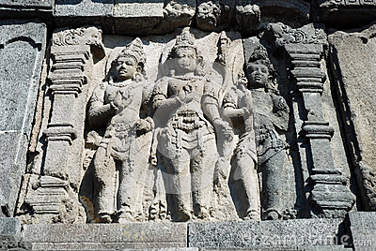

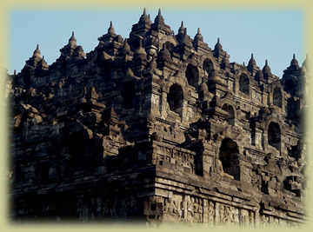

## Goa Maria Tritis - The Church of the Black Madonna

This is a very interesting “active” church in a cave amongst the stalactites, on the road to Baron Beach.

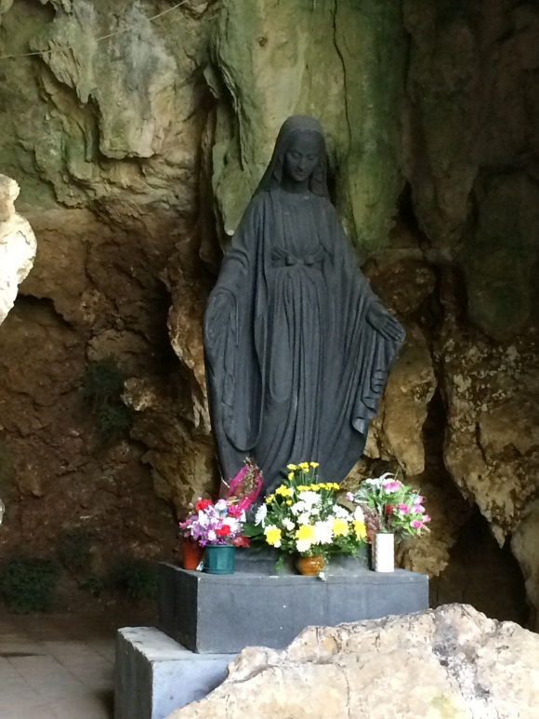

You can journey around the Stages of the Cross and pray in the church in a beautiful rural setting.

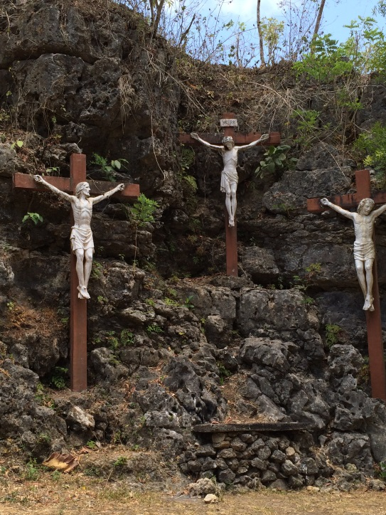

**Trekking – Gunung Prau**

For the adventurous there are some beautiful treks in un-spoilt Java. The dry season is the best time to do these treks as Heavy downpours are common in the wet season and temperatures can be quite low at altitude.

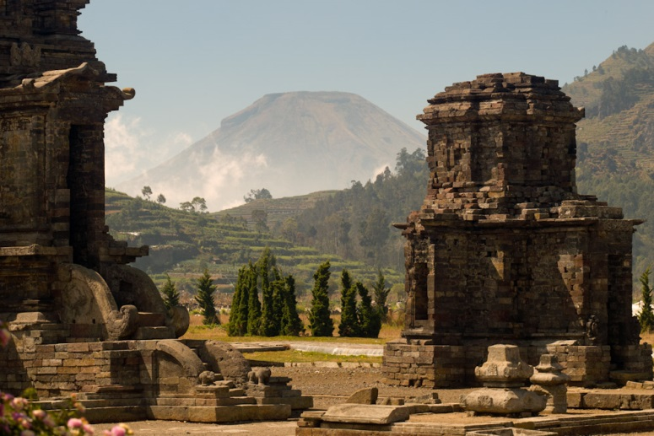

The lofty Dieng Plateau is home to the oldest Hindu temples in Java that were built between the 7th and the 9th century. The name Dieng comes from Di-Hyang (Abode of the Gods) and it is believed that this was once a flourishing temple-city. Over 400 temples were built and covered the highland plain, of which only eight small temples still remain. They are often shrouded in mist. This region is also known as the nation’s main potato growing area. The temples are simple in detail but it is the extraordinary beauty of the surroundings and the close proximity to volcanic activity with bright colored sulphur springs, lakes and bubbling mud holes that is captivating.

Especially during weekends, locals from Semarang and Yogyakarta overrun the place as they escape from the humid heat of the tropics. The landscape is simply stunning, steep mountainsides terraced with vegetable plots enclose the huge volcanically active plateau, a marshy caldera of a collapsed volcano. Many great walks can be made around the village of Dieng, or a walk or a 7 km bike ride to Java’s highest village, Sem Bungan should be a must.

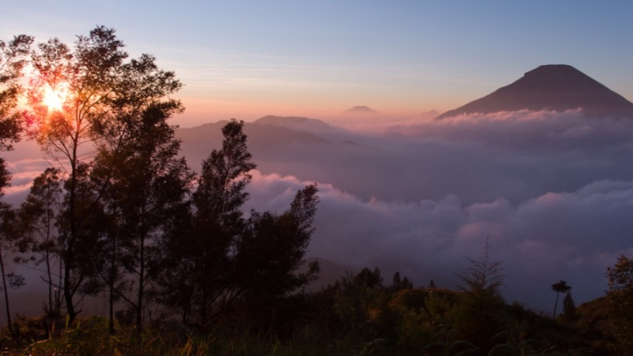

*Dieng Plateau*

## Beaches of Yogyakarta

*(All beaches other than Glagah are 1 - 1 1/2 hour’s drive from Hacienda)*

### Indrayanti

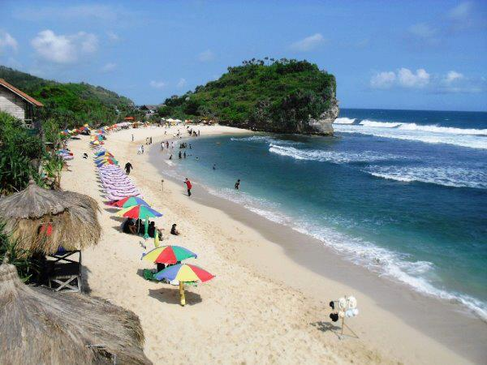

### Baron Beach

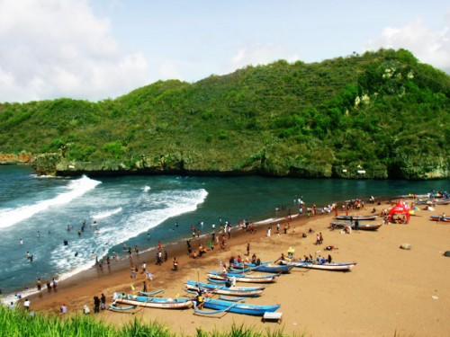

### Parangritis

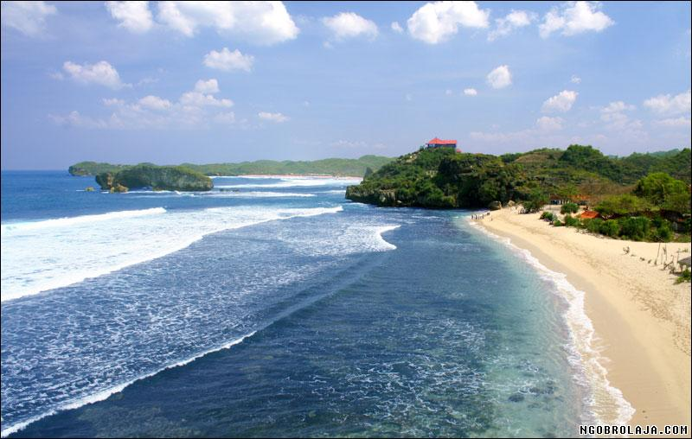

### Glagah Beach, Wates (volcanic, dark sand but close to the Hacienda)

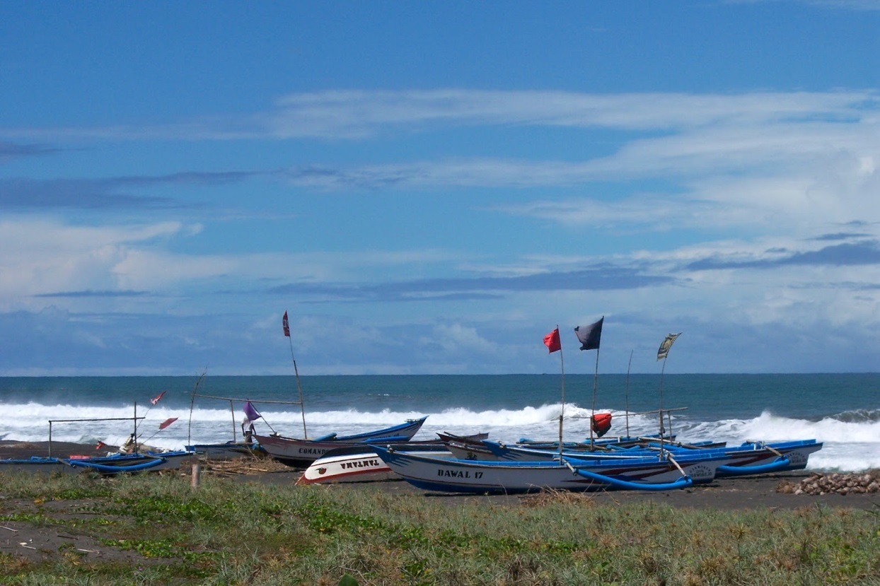

## Malioboro

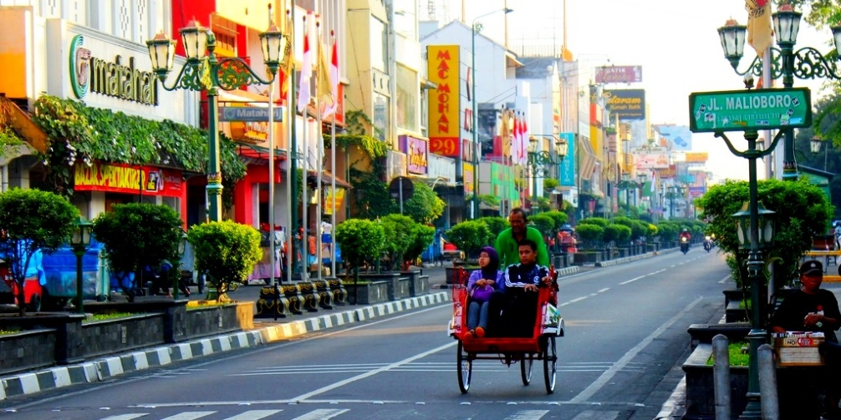

Malioboro by day

Malioboro is the most famous street in Yogyakarta. Located in the heart of Yogya, this is the city’s main street, and was once the ceremonial avenue for the Sultan to pass through on his way to and from the Keraton. During such occasions Malioboro would be festively decorated with flowers. Some say that the name Malioboro” derives from the name of the British governor Marlborough from the era when Britain ruled the archipelago, between 1811-1816.

Near the north gate of the Keraton or palace are Dutch colonial buildings that are now the Central Post Office and the Bank Dagang Negara. Walking further north is the well laid out State Guest House, which was once the home of the Dutch Resident, but which after Independence became the presidential palace when Yogya was the capital of the young Republic. President Soekarno stayed here between 1946-1949.

Across the road is the Vredenburg fort, which used to be the barracks of Dutch soldiers and is now a centre for arts and painting exhibitions.   
On the same side of the road is Bering Harjo market, Yogya’s crowded main market, where you can buy batik and souvenirs at cheap prices.     
On Malioboro you will also find Yogyakarta’s oldest hotel, the Garuda Hotel, built in Dutch colonial architecture.

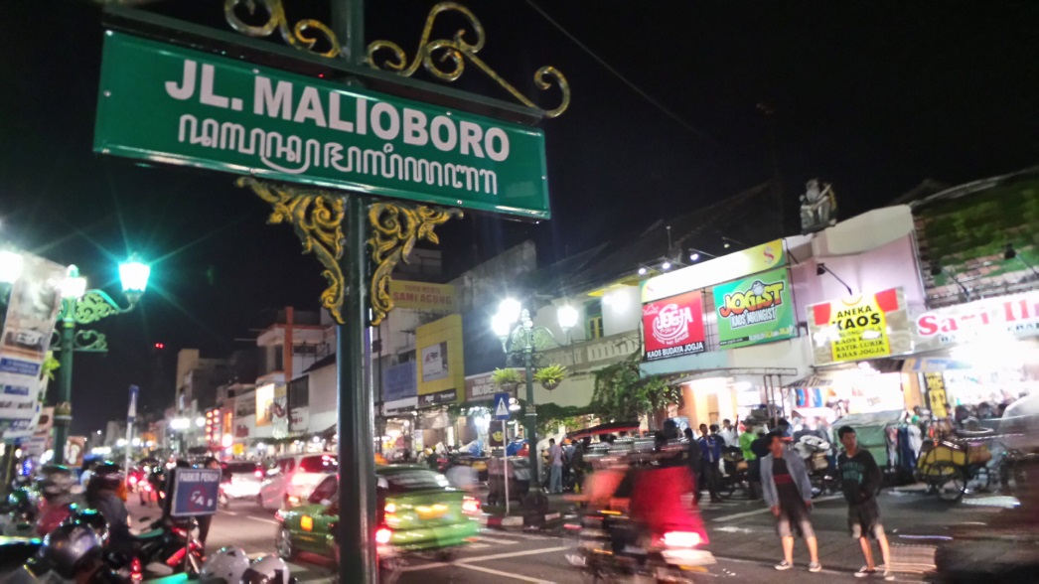

*Malioboro by night*

While steeped in history, today, Malioboro is the place to come to shop. It’s packed with shops selling curiosities, and street vendors offering souvenirs at affordable prices, so you’re bound to find something of interest in this street.

If you’re after some batik to take home as a souvenir, then Malioboro is the right place for you. From house dresses to formal batik wear, this street has them all. Batik can also be made into bags, tablecloths, bed sheets, pillow covers, curtains, and a whole lot more.

### Merapi Volcano

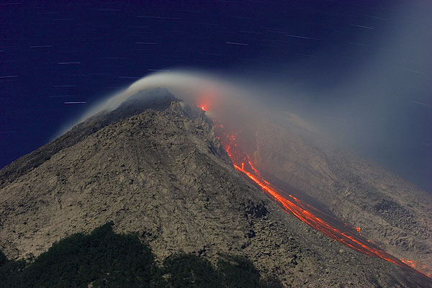

Literally "Mountain of Fire", Mount Merapi is the most active volcano in all Indonesia and it has erupted at least 68 times since 1548. The volcano is thought to be largely responsible for the downfall of the Hindu Mataram kingdom in 1006 and the desertion of the huge temple complex at nearby [Prambanan](http://wikitravel.org/en/Prambanan). Recent eruptions include 1994 (64 killed), 2006 (no immediate deaths, but a prelude to an earthquake that killed over 5000) and 2010 (30 dead).

Anyone thinking of climbing the mountain must first check if it is safe to do so. While climbing the mountain with a qualified guide is recommended it is not necessary or mandatory, as the track to the summit is wide and clearly marked. But this is not the case at night. Many routes are invisible since visibility is low as it's dangerous.

Selo is the last village on your way to Merapi. A taxi from Yogyakarta airport to Selo and back will cost you around IDR 1,000,000. Most of the drivers will happily wait for you while you climb Merapi and will take you back to your hotel.

* Yogyakarta Transport and climb for IDR 300.000 per person for groups of two or three people. Keep in mind that most of the agents require minimum two people, so if you are a solo traveller then you may have to wait for a day or two. For Merapi Camping Trips you can arrange for $250 per person with transportation from hotel/airport Yogyakarta, equipment gear tents, sleeping bag, mattress, water and meal, head lamp, professional guide and porter.

Alternatively you can hire a scooter in [Yogyakarta](http://wikitravel.org/en/Yogyakarta) and ride out to the summit. Ride north out of Yojya on Jl. Magelang for 45 min. When you reach Mungkid turn right onto Jalan Bololali - Mungkad and head towards Ketep. At Ketep turn right and continue following the Jalan Bololali - Mungkad into Selo. From Selo ride up the steep road (on the right as you come into Selo) to the trail entrance where you can leave your scooter.

#### Climbing Merapi

Avoid the rainy season which spans Late October to Early April. The slopes become slippery and the high altitude, night climate and rain makes the hike unbearably cold, especially if you are waiting for the rain to pass at one of a handful of sheds on the route up. Waterproof winter wear is necessary if you intend to brave the rains in these months and especially at night. The rainy season also means cloudy days and reduces the prospects of viewing any sunrise. Do pack a set of dry clothes to change into, since you are bound to get wet, and good hiking shoes with sufficient friction to mitigate the wet roads. The trip to base camp by car can also get hazardous as fog builds up after a downpour and visibility degrades to less than 1m.

Trekking on and around Merapi is a popular activity (at least when the volcano isn't spewing out hot gas and ash). From Selo, the nearest village on the North Slope, it is 3 hr. hike to the summit for the fit and healthy. For others it will take 4+ hr. to climb, and nearly the same time to get back down again.

Carry a small pack with some food, a good flash light, with spare batteries (available for purchase in Selo village), and at least 2 litres of water per person.

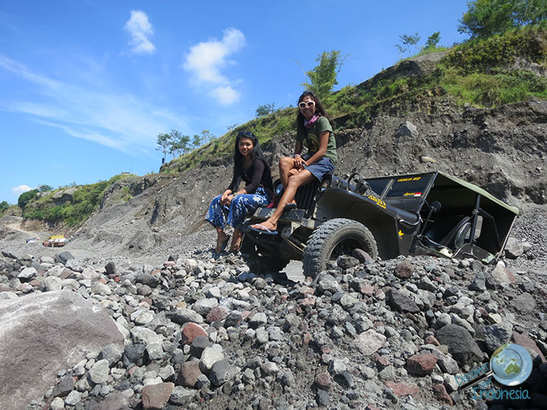

*Merapi Jeep Tour*

The track to the top is a reasonable grade and is mostly the mountain's natural water drains, a guide is recommended, can get muddy and slippery when it rains. Once through the tree line the track is less defined and the final climb to the summit (after the memorial plaque) is a very steep scramble over loose and broken rock. While not in itself dangerous, do take your time on the last section. There is a 200m section of ash which is the hardest once past the rocky section to the summit is reasonably steep but is like any other for regular hikers.

Most climbers start at about 1AM to be sure of reaching the summit by sunrise at 5.30AM. Night climbing is wise in any case, as the upper reaches of the mountain are completely treeless and the sun can fry you to a crisp. The sunrise views across [East Java](http://wikitravel.org/en/East_Java) are quite stunning.

The way back can be trickier than the rise, since the ash and the inclination of the route, make it almost impossible to stand up.

[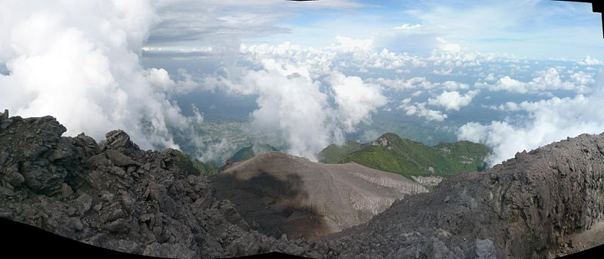](http://wikitravel.org/en/File:Java_Gunung_Merapi_Panorama_001.jpg)

*View from Gunung Merapi*

#### Tours of Merapi

There are two different types of Merapi tours available. The first is [trekking Merapi](http://discoveryourindonesia.com/mount-merapi/) (this is a hike all the way up to the summit of the volcano). The second option is the Merapi Lava Tour, where you take a 4×4 Jeep and explore the region around the base of the volcano.

# CONTACT US:

Tiyas & Tony Roderick

***Hacienda Retreat***

Desa Soropadan Rt. 09/05, Kecamatan Pengasih,

Kelurahan Tawang Sari, Kabupaten Kulonprogo

Wates – Yogyakarta, Indonesia (55652)

# Contact & Booking

*To inquire about retreat dates, availability, or customized group experiences, please contact us:*

***Email:***[tiyas.azzahra@gmail.com](https://btmail.bt.com/cp/ps/main/richui/maintab?d=btinternet.com&u=t.roderick07&t=4711d&a=contacts)

[t.roderick07@btinternet.com](mailto:t.roderick07@btinternet.com)

***Phone/WhatsApp:***Tiyas: +62 878 39046964

Tony: +62 821 34616064

*Instagram: @hacienda\_tranquility*

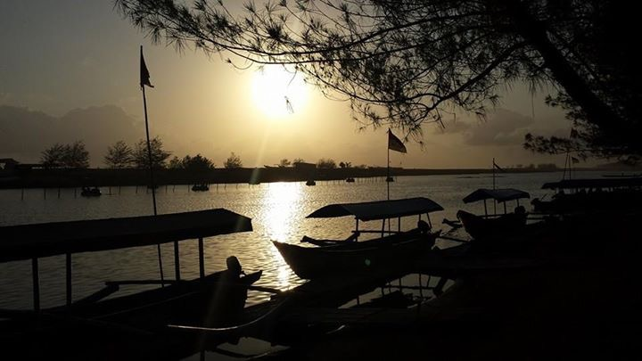

*Sunset at the local beach - Glagah*